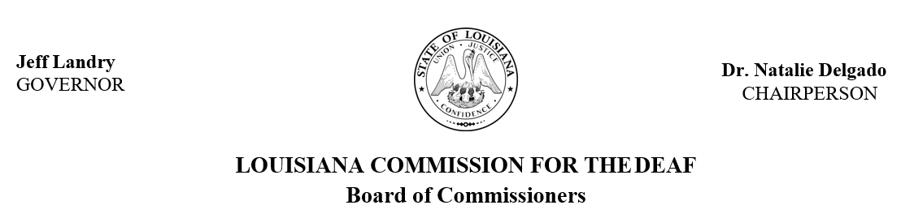

The Louisiana Commission for the Deaf (LCD) Board of Commissioners, in accordance with RS 46:2352, meets quarterly to help guide program efforts and activities related to d/Deaf, DeafBlind and hard of hearing citizens of Louisiana. Board members consists of qualified and knowledgeable members with experience which enables them to represent the concerns, needs, and recommendations of d/Deaf, DeafBlind, and hard of hearing persons and their families.
Members include individual representatives who are d/Deaf, DeafBlind and hard of hearing, parents, professionals, representatives from related state organizations, and the state legislature.
2026 LCD Board of Commissioner Public Meetings will take place on the following dates from 9:00 am – 1:00 pm. These meetings are open to the public. Locations may vary.

2026 Public Meeting Dates
- January 16, 2026
- April 17, 2026
- July 17, 2026
- October 16, 2026

Full agenda will be posted two weeks prior to each meeting date. Be sure to visit LCD’s website at https://lcd.la.gov/commission-board/ for more information.
American Sign Language (ASL) interpreters and live captioning are provided by LCD for all public meetings. Presenters, members, and guests may submit requests for additional accessibility and accommodations prior to a scheduled meeting. Please submit a request to jazmyne.lemar@la.gov at least one week prior to the meeting with details of the requested accommodations.

In lieu of verbal public comment, individuals may submit a prepared statement in accordance with Senate Rule 13.79. Statements should be emailed to jana.broussard@la.gov and must be received at least 24 hours prior to the meeting to be included in the record for the meeting.

To help us ensure our meetings are fully accessible, please share your meeting experience by completing this form https://redcap.link/opovdjk0

